Reply for M4-discussion 1:

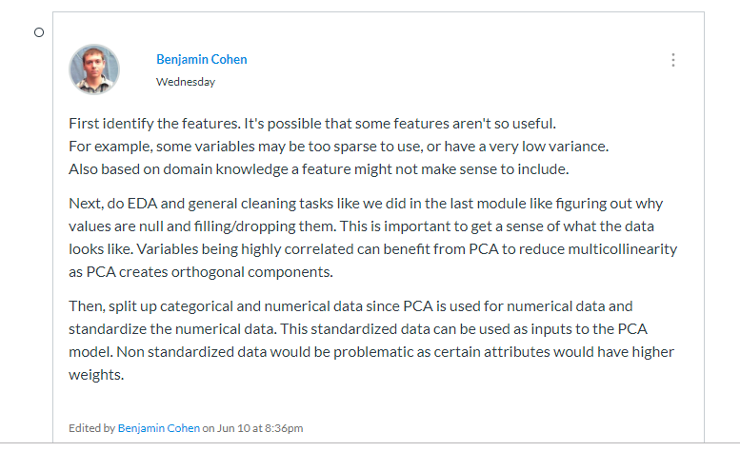

Hi Benjamin, I think this is a very good point that you mentioned here, I have never though about to split the categorical and numerical variables in the process of using PCA, now I knew that the PCA can only be applied to numerical data. Thanks.

Reply for M4-discussion 2:

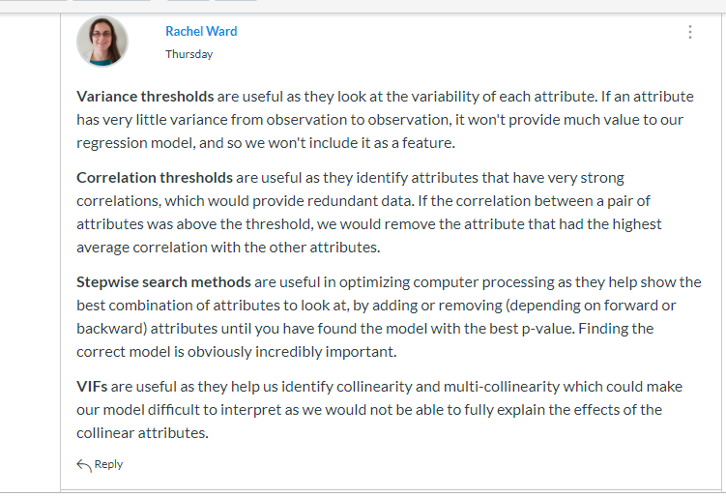

Hi, Rachel. Thanks for your explain here. I just have a small question here, like you said we should remove the one with the highest correlation in correlation thresholds? This is a point that I am not fully understand, will do more research later on.